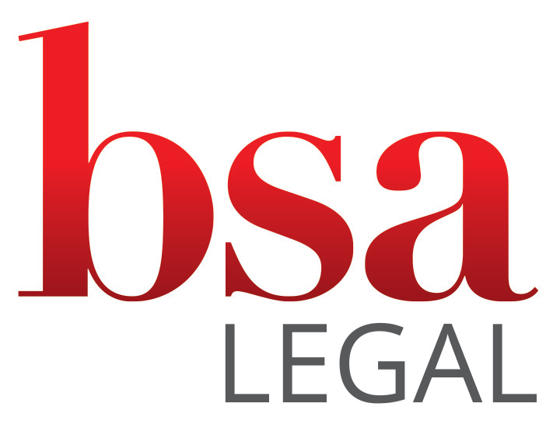

Privacy Notice

Privacy Notice
Immigration Support Services
Updated October 2026 · Next review October 2027
1. Introduction
BSA Group Legal Services Ltd (“BSA Legal”, “we”, “us”) is a UK-based legal services provider offering immigration and legal support to UK independent schools, international students and their families. We are registered in England and Wales (company number 13634894) and are authorised and regulated by the Solicitors Regulation Authority (SRA number 8003074).
When we give legal advice and prepare visa applications, we are a data controller under the UK General Data Protection Regulation (UK GDPR), and this notice applies. When a school instructs us to assign Confirmations of Acceptance for Studies (CAS) or to keep its sponsor records, we act as the school’s processor: the school is the controller, its own privacy notice applies, and we use the data only on the school’s documented instructions, under the data processing clause in our terms of business.
We are committed to protecting personal data and to meeting our obligations under the UK GDPR and the Data Protection Act 2018. This notice explains what personal data we collect, how we collect, use, share, transfer and store it, the purposes and lawful bases for processing, how long we keep it, and your rights. It also summarises how we respond to personal data breaches.
You can contact us, or our Data Protection Lead, at:
BSA Group Legal Services Ltd, 50 Princes Street, Ipswich, Suffolk, IP1 1RJ
Email: legal@bsalegal.co.uk Tel: +44 (0)207 798 1583
2. What personal data we collect
We may collect and process the following types of personal data:
- Student and parent/legal guardian names and contact details
- Educational guardian names and contact details
- Nationality and immigration status information (e.g. right to study), including copies of passports
- Signed parental consent letters
- Birth certificates and certified English translations
- Interview notes and other records relied upon to make an offer
- Confirmation of Acceptance for Studies (CAS) details
- Evidence of funds and other financial information required for a visa application, and payment details for our fees
- Previous immigration history records or information held
- Any criminal convictions that must be declared in a visa application
- Other data reasonably required to support the visa application process
3. How we collect your data
In some cases, personal data is provided to us by the school or its authorised representatives acting on behalf of the student and their family. We may also collect data directly from you, your legal representative, or your appointed agent.
4. Why we process your data
We process your personal data in order to:
- Advise and support families with UK Child Student / Student visa applications
- Prepare and submit visa applications on your behalf
- Assign CAS and keep sponsor records on a school’s instructions, as the school’s processor
- Comply with our legal and regulatory obligations as a legal services provider
5. Lawful basis for processing
Where a school instructs us, our lawful basis under the UK GDPR is Article 6(1)(f) – legitimate interests, to provide immigration support services as instructed by your child’s school. Where you instruct us directly, our lawful basis is Article 6(1)(b) – performance of our contract with you. We also rely on Article 6(1)(c) – legal obligation – to meet our legal and regulatory obligations, including record-keeping required by the SRA.
Where we process special category data (for example medical information), we do so under Article 9(2)(f) – establishment, exercise or defence of legal claims – and, where the processing is necessary to deliver the service rather than in connection with a legal claim, under such other condition in Article 9 and the Data Protection Act 2018 as applies. We will identify the appropriate condition for the specific data concerned.
Where a visa application requires us to process information about criminal convictions, we do so under paragraph 33 of Schedule 1 to the Data Protection Act 2018 (legal claims and legal advice).
6. Automated decision-making
We do not use your personal data for automated decision-making or profiling. All immigration assessments and application support are reviewed by appropriately qualified personnel.
7. Who we share your data with
We may share your data with:
- The Home Office or UK Visas & Immigration (UKVI), for visa application purposes
- Your child’s school, where necessary for coordination, and to carry out its instructions where we act as its processor
- Your nominated agent or representative (if applicable)
- Carefully selected third-party service providers who assist us in delivering our services (for example, specialist immigration casework support). These providers process personal data only on our documented instructions, are subject to strict confidentiality and security obligations under a written data processing agreement, and may not use the data for their own purposes.
- Our parent company, The BSA Group Services Limited (trading as Abitas Group), which employs our staff and provides our IT systems under a written agreement with us
We do not sell or rent personal data to third parties.
8. International data transfers
Where necessary, data may be accessed from outside the UK (for example by you, your agent, or a service provider supporting your matter). Any such access is subject to our prior authorisation and to appropriate safeguards, including UK adequacy regulations or the International Data Transfer Agreement, and secure transmission and storage protocols.
9. How long we keep your data
We retain personal data only for as long as necessary for the purpose for which it was collected and to meet our legal and regulatory obligations. Our principal retention period for client and matter files is 6 years from the conclusion of the matter (and longer where a specific matter requires it). Anti-money laundering and client due diligence (KYC) records are retained for 5 years from the end of the business relationship and then securely deleted, in line with the Money Laundering Regulations 2017. Records we hold as a school’s processor are returned to the school or deleted at the end of our services, as the school chooses, unless the law requires us to keep them. Other personal data is kept only for as long as necessary for the purpose for which it is held.
10. Personal data breach notification
If we become aware of a personal data breach, we will assess its nature and severity without undue delay and, in any event, within 24 hours of becoming aware of it.
If the breach is likely to result in a risk to the rights and freedoms of individuals, we will notify the Information Commissioner’s Office (ICO) without undue delay and, where feasible, within 72 hours. If the breach is likely to result in a high risk to individuals, we will also notify the affected individuals without undue delay.
Where we act as a school’s processor, we will notify the school without undue delay after becoming aware of a breach, so that the school can decide whether it needs to report it.
All breach incidents are recorded internally, and appropriate mitigation measures are documented and implemented.
11. Data subject rights – procedure
We respect and facilitate individuals’ rights under UK data protection law. When we receive a request (including for access, rectification, erasure, restriction, objection or data portability), we will:
- Acknowledge the request within 5 working days of receipt;
- Respond in full within one calendar month from the date the request is received; and
- Where a request is complex or numerous, extend the response time by up to two further months, notifying you within the initial one-month period and explaining the reason for the delay.
Where we hold the data as a school’s processor, we will pass your request to the school promptly and help it to respond.
Requests should be made in writing to legal@bsalegal.co.uk, marked for the attention of the Data Protection Lead.
12. Your rights
You have rights under data protection law, including the right to access your data; to rectify inaccuracies; to object to processing; to request erasure or restriction; and to data portability where applicable. You may contact us to exercise any of these rights.
If you are unhappy with how we handle your data, please tell us first using the details above. We will acknowledge your complaint within 30 days, investigate it without undue delay and tell you the outcome. You also have the right to lodge a complaint with the Information Commissioner’s Office (ICO) at ico.org.uk.

