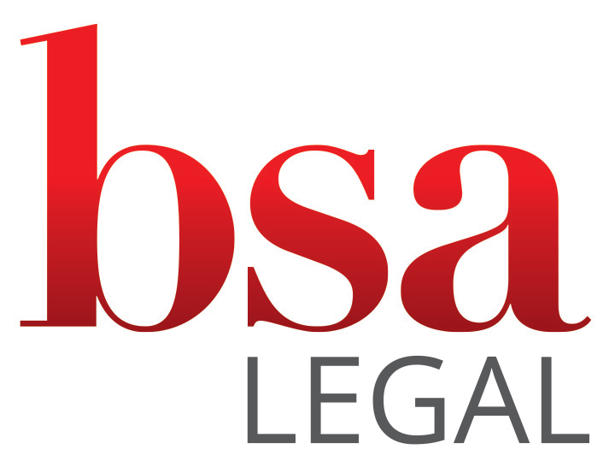

Complaints Policy

Complaints Policy
October 2026 · Next review October 2027
1. Our commitment
BSA Legal is the trading name of BSA Group Legal Services Ltd, a company registered in England and Wales (number 13634894), authorised and regulated by the Solicitors Regulation Authority (SRA number 8003074). Our registered office is 50 Princes Street, Ipswich, Suffolk, IP1 1RJ.
We want to give a high standard of service. If something has gone wrong, we want to know so that we can put it right. Making a complaint is free, and it will not affect the way we treat you or your matter.
This policy applies to complaints from our clients about our service or our charges. We also welcome concerns from anyone else affected by our work, such as a family we have supported on behalf of their child’s school. We will look into those concerns in the same way, although the right to go to the Legal Ombudsman (section 4) is generally limited to clients.
We will give you this policy when you first instruct us, at the end of your matter, whenever you ask for it, and if you raise a complaint. If you need it in a different format, for example large print or a translation, please tell us.
2. How to make a complaint
You can complain in any way that suits you:
- Email: legal@bsalegal.co.uk (please put “Complaint” in the subject line)
- Phone: +44 (0)20 7798 1583
- Post: Complaints Manager, BSA Legal, 50 Princes Street, Ipswich, Suffolk, IP1 1RJ
It helps us if you can tell us:
- your name and contact details, and the school or pupil the matter relates to;
- what went wrong and when;
- what you would like us to do to put it right.
You do not need to use the word “complaint”. If you raise a concern with anyone at BSA Legal and want it treated as a complaint, we will do so. If you need help putting your complaint in writing, we can take the details by phone and confirm them back to you.
3. What happens next
1. Acknowledgement. We will acknowledge your complaint in writing within 5 working days. We will tell you who is handling it and when you can expect our response.
2. Investigation. Our Complaints Manager will oversee your complaint. The person who reviews it will not be the person whose work you are complaining about. Where the complaint concerns our Director, it will be reviewed by a member of our Legal Advisory Board or an independent solicitor. We will look at the file, speak to the people involved, and may ask you for more information.
3. Updates. If the investigation takes longer than expected, we will tell you why and give you a new date.
4. Our final response. We will write to you with our findings, what we propose to do, and your options if you are not satisfied. We aim to send this within 4 weeks, and in any event within 8 weeks of receiving your complaint.
If we find we got something wrong, we may offer an apology, put the matter right, reduce or refund our fees, or change how we work. We keep a record of every complaint and what we learned from it.
4. If you are not satisfied: the Legal Ombudsman
If we have not resolved your complaint to your satisfaction within 8 weeks, or you are unhappy with our final response, you may be able to ask the Legal Ombudsman to look at it. The Legal Ombudsman is free and independent. We cannot resolve your complaint with them on your behalf.
Who can use the Legal Ombudsman. Usually only clients can complain, and only if they are:
- an individual;
- a business with fewer than 10 employees and turnover or assets of no more than €2 million;
- a charity, club, association or society with an annual income (net of tax) of less than £1 million; or
- a trustee of a trust with assets of less than £1 million.
Many schools have an income of £1 million or more, in which case they cannot use the Legal Ombudsman. If you are unsure, the Legal Ombudsman can tell you.
Time limits. You must normally complain to the Legal Ombudsman:
- within 6 months of our final response, as long as that response told you about the Legal Ombudsman; and
- no later than 1 year from the date of the problem, or 1 year from when you should reasonably have known there was cause to complain.
The Legal Ombudsman may extend these limits in exceptional circumstances.
Contact details
- Website: www.legalombudsman.org.uk
- Email: enquiries@legalombudsman.org.uk
- Phone: 0300 555 0333
- Post: Legal Ombudsman, PO Box 6167, Slough, SL1 0EH
Alternative dispute resolution. Independent bodies approved by the Chartered Trading Standards Institute can help resolve complaints about legal services, if both you and we agree to use one. A list of approved bodies is available at www.tradingstandards.uk. We do not currently agree to use an alternative dispute resolution body. This does not affect any right you have to complain to the Legal Ombudsman.
5. Complaints about your bill
If you are unhappy with our bill, please raise it with us first under this policy. If we cannot resolve it, you may be able to complain to the Legal Ombudsman as set out in section 4.
You may also have the right to ask the court to assess our bill under Part III of the Solicitors Act 1974. Strict time limits apply, usually starting from the date you receive the bill, and the right may be lost once the bill has been paid. If you ask the court to assess the bill, the Legal Ombudsman may not be able to consider a complaint about it.
6. Raising concerns with the Solicitors Regulation Authority
The Legal Ombudsman deals with the quality of our service. The Solicitors Regulation Authority (SRA) deals with professional conduct. You can raise a concern with the SRA at any time if you think we have acted dishonestly, mishandled money, discriminated against you, or otherwise breached the SRA’s standards.
- Website: www.sra.org.uk/consumers/problems
- Phone: 0370 606 2555
- Post: Solicitors Regulation Authority, The Cube, 199 Wharfside Street, Birmingham, B1 1RN
7. Complaints about how we use your personal data
If your complaint is about how we have handled your personal data, please send it to us in the same way, marked “data protection”. We will acknowledge it within 30 days, investigate it without undue delay, and tell you the outcome. Our privacy notice explains how we use personal data.
If you are not satisfied, you can complain to the Information Commissioner’s Office at ico.org.uk/make-a-complaint or on 0303 123 1113.
8. Records and review
The Complaints Manager keeps a log of every complaint, including the date received, the issue, who reviewed it, the outcome, the date of our final response, and any changes made as a result. The Director reviews the log every 6 months to identify patterns or recurring issues, and reports a summary to the Legal Advisory Board.
This policy is approved by the Director of BSA Legal and reviewed every year, or sooner if the law or SRA requirements change.
Version: 2.0, October 2026. Next review: October 2027.

