
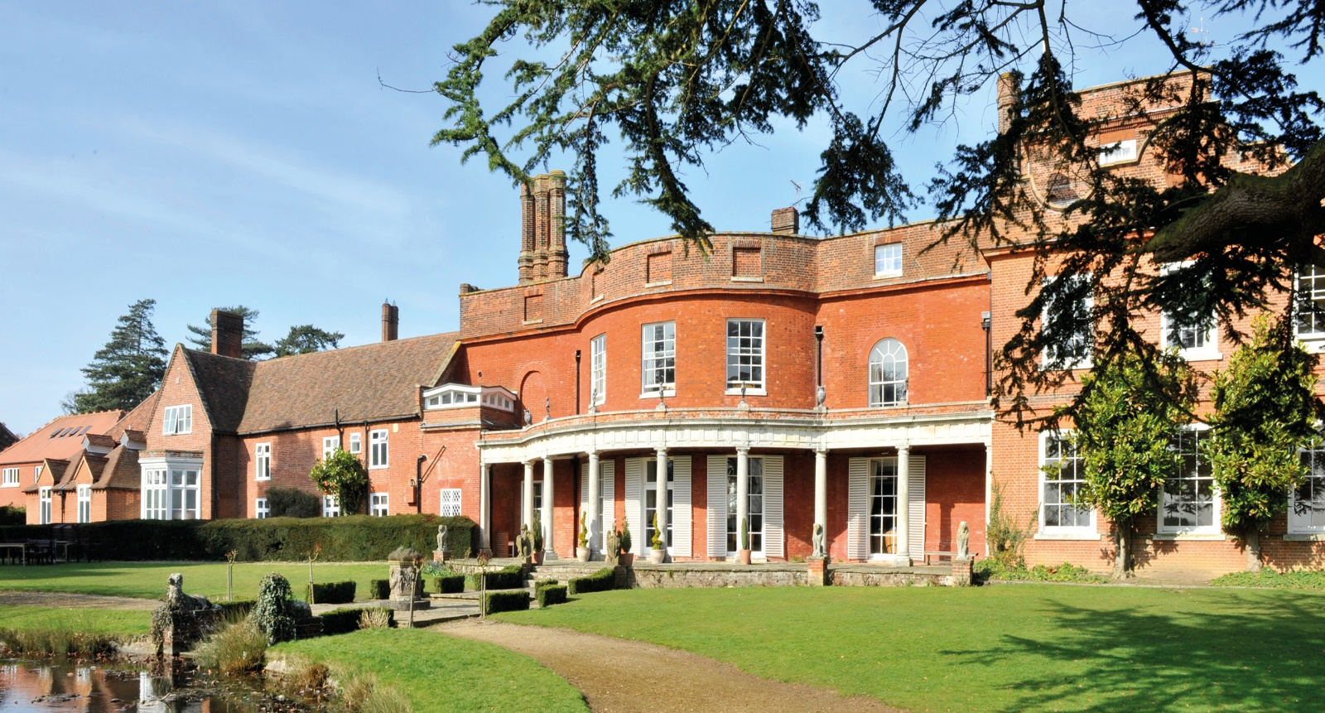

APPOINTMENT OF
MATRON/BOARDING ASSISTANT




MATRON
Working Hours:
Term time (34 weeks) + 2 days at the beginning and end of each term.
4 weeks Annual Leave plus 8 Bank Holidays paid.
Working on a rota system including wake ups/evenings/on call over- night and weekends.
Salary: £28,770 Gross £21,135 Prorated (above hours and weeks)
Accommodation: Residential /Non-Residential – Accommodation available if necessary.

General Information for Candidates

Old Buckenham Hall was founded in 1862 by Ellen and Margaret Ringer. In the 158 years that have followed, the School has become known as one of the leading Pre-Preparatory and Preparatory schools in the country. A co-educational school for children aged three to 13, we serve a boarding and day community and send children on to some of the best public schools in the UK. Many of these pupil’s leave having achieved scholarships. Regular destinations include Eton, Harrow, Oundle, Uppingham and Rugby, as well schools in the Cambridge area and in East Anglia. The School firmly believes in a rounded education, where there is a strong emphasis on pastoral care and opportunity for all. We believe that happy children who are well taught are given an outstanding platform for future success.

Job Description

Role | Matron
Job Purpose | To contribute to the pastoral care, health and wellbeing of pupils.  To promote a happy and successful community in the boarding house by taking an active interest in the pupils.  The Matrons are responsible for overseeing the domestic running of the Boarding Houses; these will include cleaning, laundry, maintenance, health and safety and medical arrangements for individual pupils. They will be required to liaise with the Senior Matron, Head of Boarding and/or tutors, as well as parents.
Accountable to: | Senior Matron and Head of Boarding
Accountabilities | Medical Matters  - To be aware of individual pupils’ health problems  - Provide first aid assistance to pupils with minor illness  - To respond to medical emergencies as well as routine appointments, escorting pupils to attend medical, dental or other health appointments as needed.  - To administer any medication in accordance with school protocol.  - To ensure that administration of pupil accidents, medical and drug dispensing records are kept up to date using iSAMs medical centre.  - Ensure the Surgery medical cabinet and fridges are secure.  - Caring for pupils in Sickbay.  - To regularly perform checks for head lice  - Liaise with the Senior Matron and Head of Boarding in order to share any health or medical concerns.  - To regularly update a First Aid Paediatric qualification.  Pastoral  - To be responsible (with the Senior Matron, Head of Boarding & Tutors) for the care, supervision, cleanliness and presentation of pupils in the boarding houses, co-ordinating and liaising with other boarding staff as necessary.  - To wake boarders, ensure they well presented for breakfast and to supervise pupils tidying their dormitories and making their beds before breakfast.  - To tidy dorms daily and check for wet beds  - To serve morning snack  - To liaise with parents and/or guardians of students in the houses about matters concerning domestic, welfare and medical issues, in consultation with the Head of Boarding.  - To contribute to the induction arrangements for new pupils joining the house and to ensure that any ‘settling in’ problems are discussed with the Senior Matron, Head of Boarding and Tutors.  - To provide a sympathetic presence in the house, and to be sensitive to those who are having difficulties coping with school life and to liaise closely with other relevant staff concerning the progress and welfare of pupils.  - To uphold the disciplinary ethos of the school by encouraging good manners and promoting respect for school property and personal possessions  - Monitor student welfare and behaviour and record any concerns on iSAMs/CPOMs  - To eat with and supervise the children at supper  - Supervise pupils at bedtime, bathing, showering and hair washing  - To maintain a reliable and supportive presence  - To be available (when on duty) during the night if needed by boarders  Domestic  - To be aware of the uniform and clothing requirements of pupils. To organise house laundry, undertake repairs, alterations and dry cleaning of clothing and bedding.  - To check dormitories, changing and laundry rooms for obvious dirty clothes and instruct laundry to wash any games kit or other urgent items.  - To assist with the beginning and end of term arrangements for sorting trunks and linen allocation.  - To liaise with the Domestic Manager and Head of Boarding in the preparation of the boarding house for any holiday lettings from external organisations.  - At the end of term, to assist in the clearing up and cleaning of the houses; to carry out a check of all bedding, furniture, fixtures and fittings, preparing a list of repairs and maintenance and to advise the Domestic Manager/Estates Manager about the replacement or renewal of bedding, fixtures and furnishings.  - To ensure the safe storage of domestic materials in line with COSHH requirements.  Health & Safety  - To participate in the statuary termly fire evacuation, reporting any problems to the Head of Boarding and Health and Safety Co-ordinator.  - To assist with the annual Boarding House Health and Safety Audits in consultation with the Head of Boarding and the Health & Safety Co-ordinator.  - To assist Maintenance with Electrical Equipment Health Checks of all pupils’ personal electrical appliances in the boarding house; to remove any unsafe electrical goods in house that may pose a Health & Safety risk; to record any items removed and liaise with Head of Boarding.  General  - To be familiar with the National Minimum Boarding Standards for Boarding Schools and ensure compliance with them.  - Undergo a biannual appraisal in line with the current system.  - To attend house boarding staff meetings as required by the Head of Boarding.  - To be familiar with the school’s code of practice for health and safety, and its policies and procedures for countering bullying, substance misuse and child protection; to be willing to undertake additional training as required by the School.  - To be available to join weekend/evening boarding activities as required  - Matrons are expected to undertake a number of statutory courses as arranged by the school
General requirements | All school staff are expected to:  - Work towards and support the school vision and the current school objectives outlined in the School Development Plan.  - Support and contribute to the school’s responsibility for safeguarding students.  - Work within the school’s health and safety policy to ensure a safe working environment for staff, students and visitors  - Promote equality of opportunity for all students and staff, both current and prospective.  - Maintain high professional standards of attendance, punctuality, appearance, conduct and positive, courteous relations with students, parents and colleagues.  - Engage actively in the performance review process.  - Adhere to policies.  - Undertake other reasonable duties related to the job purpose required from time to time.
Review and Amendment | This job description should be seen as enabling rather than restrictive and will be subject to regular review.

Person Specification

Skills Required
Commitment to safeguarding the physical, emotional and mental well-being of young people. | Essential
Understand the importance of developing appropriate working relationships with young people. | Essential
Possess effective communication skills, both written and spoken, for dealing with pupils, parents and staff. | Essential
Ability to work well in a team | Essential
Ability to work quickly and calmly under pressure | Essential
Ability to prioritise and manage own work | Essential
Proficient IT skills | Essential

Knowledge Base
Qualifications/Attainment
Clean Driving licence  Food hygiene certificate  Pediatric First Aid certificate  Level 2 safeguarding child protection qualifications | Essential  Desirable  Desirable  Desirable

Experience
Residential care or Boarding-school Matron | Essential
Nursing | Desirable
Working with children out of their home environment or in an educational or medical environment | Essential

Attitude/approach
Ability to motivate and work with pupils | Essential
A willingness to work unsociable hours, including weekends and evenings | Essential
Trustworthy, dependable and reliable | Essential
Internationally aware and culturally sensitive | Essential
Ability to develop a culture of mutual respect with pupils | Essential
Emotional resilience | Essential
A caring disposition and an empathy with and understanding of young people | Essential
High level of discretion | Essential
Good manner with parents and guardians, and other staff | Essential
Patient, unflappable, flexible and adaptable | Essential
Enthusiastic with a good sense of humour | Essential

We are looking to appoint staff, who are committed in their approach to education as well as keen to explore and contribute fresh ideas. Most importantly, we seek colleagues, who are willing to throw themselves into the broader life of the School, but do so with enthusiasm and a sense of humour. In return, we offer a beautiful working environment within rural Suffolk.

Old Buckenham Hall School is committed to safeguarding children and expect all staff and volunteers to share this commitment.
All successful applicants must be willing to undergo child protection screening appropriate to the post including checks with any past employer and the Disclosure and Barring Service.

