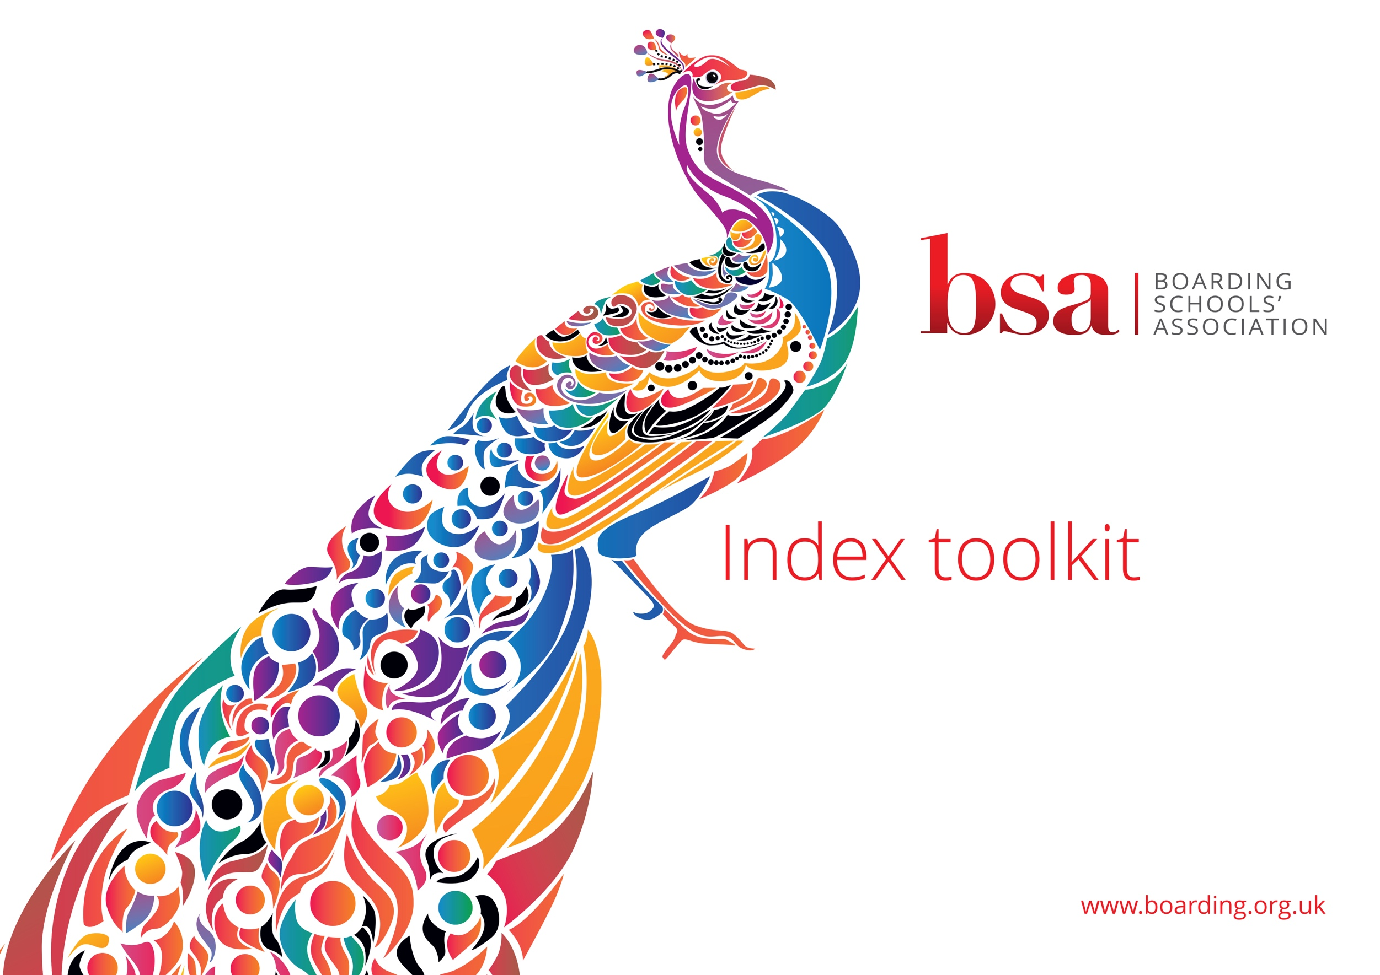
Index Toolkit

This Toolkit, based on the Index Framework, provides structure and guidance to promote the values of equity, diversity and inclusion and seeks to assist schools to be more effective and thus provide a better service as both an educational establishment and an employer.
Statement of Intent | - Key points of Discussion  - Evidence | - Action Points | By when | By whom
Commit to building a school culture that firmly embeds equity, diversity and inclusion – thereby creating a sense of belonging whereby every member of the school community feels valued
Acknowledge the many positive aspects which diversity and inclusion bring to a school community and boarding sector as a whole
Prioritise the development of best practice for Index and demonstrate this commitment by including it in the school’s development plan
Empower staff and pupils to create change
Leadership | - Key points of Discussion  - Evidence | - Action Points | By when | By whom
Appoint a Designated Inclusion Governor
Embed best practice whereby the Head and SLT members take the lead regarding this work
Appoint an Inclusion Lead (SLT member) who is provided with appropriate support, training and time
Create an Index working group which meets regularly to identify and plan specific actions
Appoint a pupil Inclusion Lead (member of the senior prefect team)
Include Index matters as part of the staff appraisal process
Audit and Action Plan | - Key points of Discussion  - Evidence | - Action Points | By when | By whom
Conduct a full audit of the current provision, policies and ethos of the school in respect of Index
Develop an action plan which will be regularly updated
Report progress to the Governors termly as a matter of routine
School Environment | - Key points of Discussion  - Evidence | - Action Points | By when | By whom
Create an inclusive culture and environment in which all staff and pupils can positively engage and develop their self confidence
Ensure that all staff are aware of their responsibilities and of the behaviours expected through training, consistent messaging, and role modelling from Senior Leaders
Training | - Key points of Discussion  - Evidence | - Action Points | By when | By whom
Embed support and development for all staff and governors
Organise specific and additional training as identified
Practice | - Key points of Discussion  - Evidence | Action Points | By when | By whom
Create opportunities for staff and pupils to discuss views and ideas within a respectful, constructive and professional environment in which challenging and robust conversations are integral
Include Index as an agenda point for whole staff meetings as well as for departmental and other teams
Develop transparent procedures in respect of how concerns or complaints should be properly raised. Absolute clarity that any issue brought forward in good faith will be taken seriously
Commit to reflection upon and learning from both internal and external matters
Establish a Pupil Index working group to discuss current issues
Establish a Parent Index working group to discuss current issues
Consider carefully and develop good relationships with the local community in respect of Index matters
Policies | - Key points of Discussion  - Evidence | Action Points | By when | By whom
Develop an Index policy which is compliant with the law and reflective of best practice; it should be reviewed annually by governors
Review all policies and guidance with an ‘Index lens’ and ensure clarity, consistency and practical feasibility of delivery
Introduce and maintain an incident record of discriminatory occurrences - for both staff and pupils
Curriculum | - Key points of Discussion  - Evidence | Action Points | By when | By whom
Commit to creating an inclusive and diverse curriculum by reviewing schemes of work at a departmental level and identifying whole school opportunities
Create time for pupils to discuss Index themes
Recruitment | - Key points of Discussion  - Evidence | Action Points | By when | By whom
Commit to being an equal opportunity, diverse and inclusive employer
Develop realistic targets for maintaining or increasing diversity and inclusion in school
Review the recruitment process

